Smart Parenting App with AI-Based Child Activity Monitoring

A Capstone Project
Presented to
The Faculty of the College of Technology
Lyceum of the Philippines University

In Partial Fulfillment
of the Requirements for the Degree
Bachelor of Science in Information Technology

By:
Jordan Roy F. Dolina

December 2025

APPROVAL SHEET

In partial fulfillment of the requirements for the degree Bachelor of Science in Information Technology, this capstone project entitled “Smart Parenting App with AI-Based Child Activity Monitory” has been prepared and submitted by Jordan Roy F. Dolina is hereby recommended for pre-oral examination.
__________________________________________
Asst. Prof. Janice E. Velasquez, MSCS, PhD Cand.
Adviser

Defended in a pre-oral examination before a duly constituted panel with a grade of _______________.

__________________________________
Chairman

________________________________ __________________________
Member Member

Accepted in partial fulfillment of the requirements for the degree Bachelor of Science in Information Technology.
__________________________________
Dr. Arlene R. Caballero
Dean, College of Technology

Smart Parenting App with AI-Based Child Activity Monitoring

Jordan Roy F. Dolina
Lyceum of the Philippines University
09158497722
jordandolina@gmail.com

Abstract

ACKNOWLEDGEMENT

DEDICATION

TABLE OF CONTENTS
TITLE PAGE i
APPROVAL SHEET ii
ABSTRACT iii
ACKNOWLEDGEMENT iv
DEDICATION v
TABLE OF CONTENTS vi
LIST OF FIGURES vii
I. THE PROBLEM AND ITS BACKGROUND
1.1 Introduction of the Study 1
1.2 Objectives of the Study 2
A. General Objectives 2
B. Specific Objectives 2
1.3 Significance of the Study 2
1.4 Scope and Delimitation 2
1.5 Operational Definition of Terms 3
A. Operational Terms 3
B. Technical Terms 4
II. PRESENTATION OF RELATED LITERATURE AND STUDIES
2.1 Conceptual Framework 5
2.2 Survey of Related Literature 5
2.3 Survey of Related Studies 6
2.4 Synthesis 7
III. METHODOLOGY AND DESIGN DEVELOPMENT
3.1 Methodology 8
3.2 Data Gathering Techniques 9
3.3 Ethical Considerations 9
3.4 System Development Method 11
3.5 Requirement Specification 11
A. Development Phase (Hardware and Software) 11
B. Deployment Phase (Hardware and Software) 13
3.6 Design Analysis 13
A. Application System Diagram 13
B. Data Flow Diagram 14
C. Use Case Diagram 15
D. Activity Diagram 16
E. Systems Storyboard 17
APPENDICES
References

LIST OF FIGURES

Figure No. Figure Name Page No.

CHAPTER 1
THE PROBLEM AND ITS BACKGROUND

  - Introduction of the Study
Parenting nowadays comes with new challenges. Parents must balance work, household responsibilities, and childcare, and some especially don’t have nannies or household help. Many parents find it difficult to track or closely monitor their children’s daily activities, screen time, sleep and meals due to work responsibilities, household tasks, or the absence of household help. As a result, children are sometimes left to do screen time and unhealthy routines or activities on their own.
In recent years, mobile phones, tablets, and internet-based applications have become part of children’s everyday lives. Children now use digital devices not only for entertainment but also for learning, communication, and social interaction. While technology offers many benefits, such as access to educational resources and learning applications, it also raises concern among parents. Issues such as excessive screen time, lack of physical activity, irregular sleep patterns, and exposure to inappropriate online content are becoming increasingly common.
With advances in artificial intelligence (AI), mobile applications can provide personalized insights and support for parents. This study proposes the development of a smart parenting app that monitors children’s daily routines and uses AI to generate recommendations for healthier growth and development. AI makes it possible to analyze collected activity data, identify patterns in a child’s behavior, and provide personalized recommendations. Several studies and projects have shown that AI-based monitoring systems can help improve decision-making by transforming raw data into useful insights.

1.2 Objectives of the Study
A. General Objective
- To design and develop a smart parenting mobile app to assist parents in monitoring their children’s daily activities by using AI for activity monitoring.
B. Specific Objectives
- To design a user-friendly mobile app for parents with secure access.
- To develop an app where parents can log and track their child’s daily activities.
- To provide AI suggestions based on the data provided by the parent/s.
- To provide visual reports and alerts to help parents encourage healthier routines.
1.3 Significance of the Study
The results of this study will benefit parents, children, students, researchers and developers. Parents will have an intelligent tool for monitoring and understanding their child’s activities despite their busy schedule. With AI suggestion, they can correct and promote healthier daily habits of their child. While for students, researchers and developers, this will serve as a reference for future studies related to AI-based monitoring systems and parenting applications.
1.4 Scope and Delimitations
This study focuses on development of a Smart Parenting Mobile app with AI-based child activity monitoring. It is designed to help parents monitor and manage their children’s daily activities. The app allows parents to track important aspects of a child’s routine activities such as screen time, educational activities, sleep duration and basic nutrition habits based on the data the parents input through a simple and user-friendly application.
The app uses an AI-based analysis to review the recorded data and provides a general recommendation and reminder that may help parents encourage their children to have healthier or more balanced daily routines. The app will also present data to parents, such as activity summaries and visual reports, to make it easier for the parents to understand the changes or patterns in their child’s behavior.
The app is limited to monitoring children’s activities like screen time, educational activities and sleep duration based on the data that the parents entered. It does not include real-time tracking, GPS location tracking, video and audio monitoring or access to personal message. The app does not integrate with third-party platforms, smart sensors or wearable devices. Nutrition tracking is kept simple rather than detailed nutritional analysis or diet planning. It is limited to basic logging of meal.
The AI features are intended only to provide supportive suggestions. It is designed for general parenting support and does not specifically address children with special needs or medical conditions. This app does not replace professional medical, psychological, educational advice or parental judgement.
1.5 Operational Definition of Terms
A. Operational Terms
- Smart Parenting App – The mobile application created in this study that helps parents track, analyze, and manage their child’s daily activities with the support of digital tools and AI.
- Child Activity Monitoring – The process of collecting information about a child’s daily activities, including screen time, educational activities, sleeping habits and nutrition, through the smart parenting app.
- Parental Dashboard – The interface of the app where parents can input data and view reports, summaries, alerts and recommendations.
- Activity Logs – Where all activities made in the app are logged and can be viewed.
- AI-Based Recommendations – Generated suggestions by the AI based on the analyzed child activity data.
- Alerts and Notifications – System generated messages that inform parents of potentially unhealthy activity patterns.
- Screen Time – The recorded total amount of time the child spends using digital devices such smartphones, tablets, laptop/computer and television.
- Usability and Effectiveness – How the parents find the app easy or hard to use, understand and navigate and how it accurately monitors and provide useful information.

B. Technical Terms
- Artificial Intelligence (AI) – A technology used in the application that imitates human decision making by analyzing child activity data.
- Pattern Recognition – An AI technique used to identify recurring trends or behaviors in a child’s activity data.
- Cloud Database – An online data storage used to securely store all the data.
- User Authentication – A security process used to confirm the identity of parents and children before granting access to the app.
- Data Privacy – Safeguards used to protect data from unauthorized access or improper use.

CHAPTER 2
PRESENTATION OF RELATED LITERATURE AND STUDIES

2.1 Conceptual Framework

Figure 1. Conceptual Framework

The conceptual framework shows that Smart Parenting App follows the Input-Process-Output (IPO) model to achieve its objectives. Parents will provide the necessary information on the Parental Dashboard of the App. The App will collect and store data and will use the AI to analyze and provide information like suggestions, reports and alerts. This information will provide awareness if there is a need to change habits, routines or activity or just helpful and healthy recommendations.

2.2 Survey of Related Literature
Mobile applications are increasingly used to help parents manage their children’s daily routines, especially as children spend more time using digital devices. Many studies highlight that parenting apps commonly focus on tracking activities such as screen time, study habits, and sleep patterns. Weber et al. (2023) noted that while these apps are helpful for monitoring routines, most of them only provide basic tracking features and require parents to interpret the data on their own.

Several studies have explored the use of artificial intelligence in analyzing child-related data. Yang et al. (2025) reported that AI-based mobile applications can identify behavior patterns and provide personalized feedback, making activity data easier to understand. Martinez et al. (2024) further showed that AI models can detect changes and irregularities in children’s routines using digital data, supporting the use of AI for monitoring purposes.

Concerns about privacy and data security are also common in the literature. Maier et al. (2025) warned that some parental monitoring apps collect more data than necessary. These studies stress the importance of designing applications that protect children’s data and respect family privacy.

2.3 Survey of Related Studies
Studies have shown that mobile applications can help parents monitor and manage their children’s daily activities. Shorey et al. (2023) studied a parenting support app and found that parents who used the app regularly became more aware of their child’s routines. The study showed that simple monitoring features can already help parents stay involved in their child’s daily life.
Hodson et al. (2024) examined parents’ experiences in using a mobile parenting application. The results showed that parents appreciated features such as activity tracking, reminders, and visual summaries. However, the study also pointed out that tracking alone was not enough, and parents preferred applications that could explain the data or provide helpful suggestions.

Other studies focused on the use of artificial intelligence in monitoring children’s activities. Martinez et al. (2024) found that AI can analyze activity data and identify patterns or changes in routines that may not be easily noticed by parents. This suggests that AI can support parents by turning collected data into more useful information.
Maier et al. (2025) raised concerns about privacy and data security in parental control applications. Their study showed that some apps collect too much personal information, which may affect children’s privacy.

2.4 Synthesis

Nowadays, applications play a helpful role in supporting parents in monitoring their children’s daily routines. Parents use applications to track their children’s screen time, sleep patterns, study habits and location. This increases the awareness and involvement of the parents in their children’s daily activities. But most applications leave parents to interpret the information on their own, limiting the application’s usefulness.
The growing potential of AIs nowadays can address such limitations. AIs can analyze data, identify patterns and detect changes in routines, making the information more meaningful and actionable for parents. By integrating AI, it can improve parenting apps by providing explanations, insights and feedback rather than raw data. Despite these benefits, concerns about privacy and data security remain significant. Some applications collect excessive personal data, raising risks to children’s privacy.
Overall, the need for parenting applications that combine effective monitoring, AI-driven analysis, and strong privacy protection will support parents in managing their children’s daily activities.

CHAPTER 3
METHODOLOGY AND DESIGN DEVELOPMENT

3.1 Methodology
This “Smart Parenting App with AI-based Child Activity Monitoring” project development will follow the Mobile Development Life Cycle (MDLC) to deliver an app that meets the objective of the study and meet the users’ needs.

Figure 2: Mobile Development Life Cycle

This chapter will discuss how MDLC is used in the study from how the research was conducted, and to take into consideration how to handle data. What are the requirements to develop the app. Planning the contents and approach of the design and development of the application, up to the launching of the application.
3.2 Data Gathering Techniques
Quantitative research was the approach to obtaining numerical data for analysis through survey questions. This method will evaluate the applications’ technical performance, user experience and real-world impact. The goal is to develop an effective, usable solution to practical problems.
The survey questions are conducted online by using google forms to parents or primary child caregivers with children belonging to the age group (2 to 5 years old). They are typically selected based on their ability to provide reliable information. The respondents are informed of the purpose of the survey, which is to develop a Smart Parenting App with the applications objectives.

3.3 Ethical Considerations
Standard ethical practices and considerations are followed all throughout to maintain data privacy, integrity and confidentiality. Only necessary information was asked for in the survey, and a disclaimer was informed at the beginning of the survey. The respondents also have the choice not to answer the survey question.

A. Children’s Privacy Rights - Children have privacy rights that are different from adults and deserve special attention. Laws such as the Children's Online Privacy Protection Act (COPPA) in the United States and the General Data Protection Regulation (GDPR) in Europe provide specific safeguards for children’s personal data. However, simply following legal requirements is not enough. Ethical system design should also consider children's dignity, their growing independence, and future privacy interests.

B. Data Minimization and Purpose Limitation - Ethical data practices involve collecting only the information that is truly needed for a specific purpose and is not later used without appropriate consent. The system should implement data minimization by default, meaning that any additional data collection should require explicit opt-in from users. Data should also be stored only for as long as necessary, with clear deletion policies. Parents should be given real control over how data is collected, used and shared through detailed privacy settings.

C. Informed Consent and Assent - Obtaining meaningful consent for child monitoring presents unique challenges. Parents typically provide consent on behalf of young children, but this consent must be exercised in the child's best interests. As children grow older, their own agreement or assent becomes increasingly important, and full consent is more appropriate for adolescents.
D. Preventing Harm and Promoting Well-being – Not just avoiding privacy violations, ethical design should actively consider potential harms and aim to support children’s well-being. Potential harm includes excessive parental monitoring that weakens trust and limits a child’s sense of independence, anxiety caused by misinterpreted alerts or comparisons to developmental norms, and the reinforcement of unhealthy parenting practices.
E. Algorithmic Fairness and Bias - AI systems may unintentionally reinforce or increase existing biases found in training data or system design, which can result in unfair treatment of children from different demographic backgrounds. Such biases may appear as differences in the accuracy of activity recognition across racial or ethnic groups, the use of gender stereotypes in interpreting behavior, or socioeconomic bias in developmental assessments. To promote fairness, it is important to use diverse and representative training data, carefully assess model performance across different demographic groups, and continuously monitor the system for unequal or harmful impacts.
F. Transparency and Explainability - Parents and (age-appropriately) children should be able to understand how the AI system makes decisions, what data it relies on, and what its limitations and uncertainties are. Black-box AI models that provide recommendations without explanation can weaken trust and limit informed decision-making. Using explainable AI approaches, such as showing which features influence results, visualizing patterns of attention, or providing simple natural language explanations, can help make the system’s reasoning more transparent. However, these explanations should be truly meaningful and should not create a false sense of certainty about the system’s accuracy.

3.4 System Development Methods
Agile sprints will be used during the development and testing stages to gradually build, test, and improve the AI-based smart parenting app. Each sprint will deliver working features, allowing continuous testing and refinement.
Sprint 1: App Development (2 weeks) - The first sprint will focus on building the basic features of the smart parenting app. This included user login, the main dashboard, and simple activity logging such as screen time and daily routines. Perform basic testing to ensure the features work correctly on different devices.
Sprint 2: AI Features and Improvements (2 weeks) - The second sprint will add AI-based analysis to interpret the collected data and provide simple recommendations for parents. Perform improvements to the interface based on initial feedback, and test on feature integration, data accuracy, and device compatibility.
Sprint 3: Final Testing and Refinement (1–2 weeks) - The last sprint concentrates on system testing, bug fixing, and performance optimization. Conduct usability testing with sample users to ensure the app is easy to use and reliable before deployment.

3.5 Requirement Specification
To illustrate the requirement specifications, tables were created with graphical representations, to give a comprehensive description of the requirements. From developing (Development Phase) to using the app (Deployment Phase), the requirements are shown below.

A. Development Phase (Hardware and Software)
During the development phase, tables were created to illustrate the minimum computer hardware specifications needed by the developer and the software and tools that will be used.
Recommended Minimum Computer Hardware Specification Requirements
PROCESSOR |  Intel Core i5, or equivalent or better
MEMORY |  8GB RAM or more
GRAPHICS |  GEFORCE GTX760, or equivalent or better
Table 1: Hardware Requirements

Software Requirements
OPERATING SYSTEM | 
SOFTWARE DEVELOPMENT | 
Table 2: Software Requirements

ADD-ONS
DATA BASE | 
AI | 
Table 3: Add-ons
B. Deployment Phase
When deployed, the mobile application will work on Smartphones and Tablets (Android or IOS) (preferably not older than 2020 models) that are connected to the internet.

SMARTPHONES | 
TABLETS | 
Table 4: Mobile Devices

3.6 Design Analysis
A. Application System Diagram
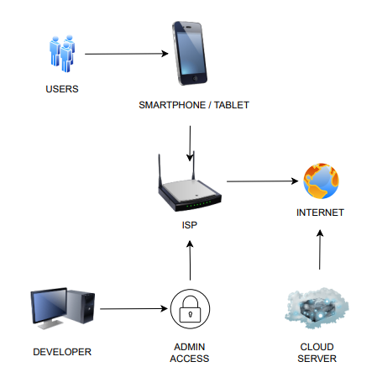
Figure 3: Application System Diagram
The figure shows the system architecture of the mobile application, where users access the app through a smartphone or tablet connected to the internet via an ISP. User data is sent to the cloud server for processing, storage, and AI-based analysis, then returned to the device as reports and recommendations. Developers manage and maintain the system through secure admin access, ensuring proper system operation and updates.

B. Data Flow Diagram
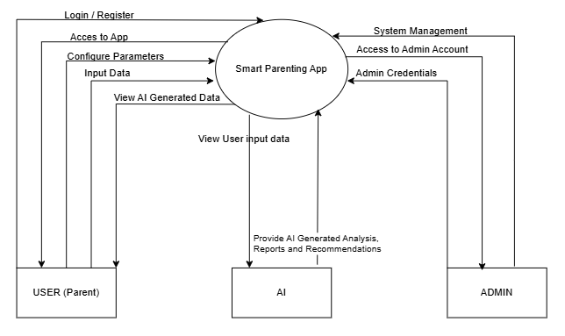
Figure 4: Data Flow Diagram

The figure presents the data flow diagram of the Smart Parenting App, showing how users (parents), the AI module, and the admin interact with the system. Parents log in, input data, configure parameters, and view AI-generated insights through the application. The AI component processes user input to generate analyses, reports, and recommendations, which are returned to the app. Administrators access the system using admin credentials to manage system functions and oversee overall application operations.

C. Use Case Diagram
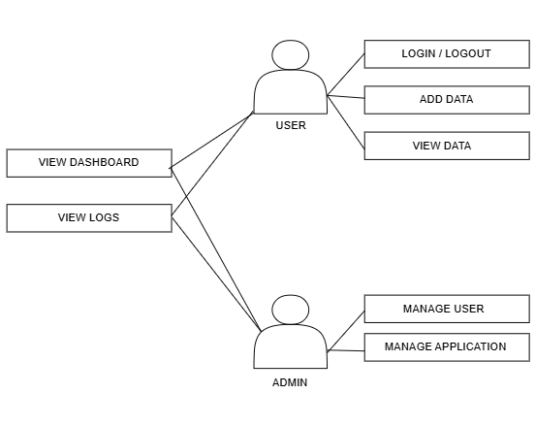
Figure 5: Use Case Diagram

The figure illustrates the use case diagram of the system, showing the interactions between the user and the admin. Users can log in or log out, add data, and view stored information, as well as access the dashboard and activity logs. Administrators have additional privileges, including managing users and overseeing overall application functions, ensuring proper system control and maintenance.

D. Activity Diagram
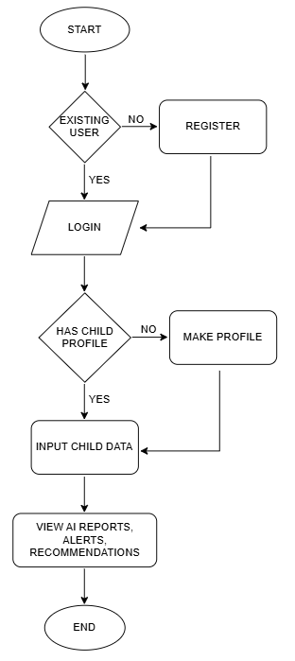
Figure 6: Activity Diagram

The figure illustrates the user flow of the application. The process starts by checking whether the user already exists; new users are directed to register, while existing users proceed to log in. After logging in, the system verifies if the user has an existing child profile—if not, the user is prompted to create one. Once a child profile exists, the user inputs child data, after which the system displays AI-generated reports, alerts, and recommendations, concluding the process.

E. Systems Storyboard
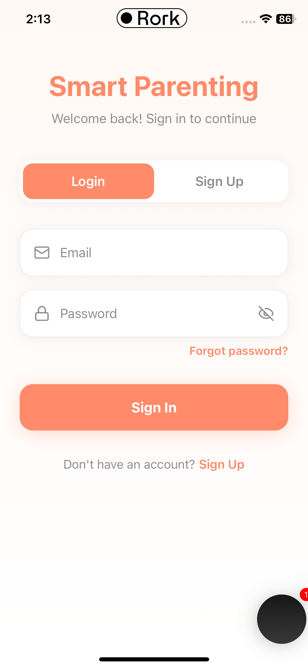
Figure 7: Login Page

This is the login page where the user can log in using their existing account to access the application. The user just must enter the email address and password they used when they signed up.
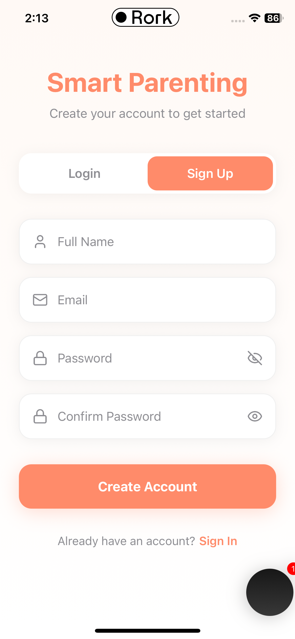
Figure 8: Signup Page

This is the signup page where the user can make an account to access the application. The user must provide the following entries to sign up for an account.
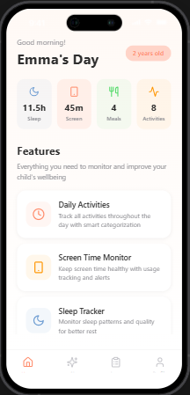
Figure 9: Home Page

This is the home page where you can see the summary of the child’s data. Shortcuts can also be seen here to access the modules you want.

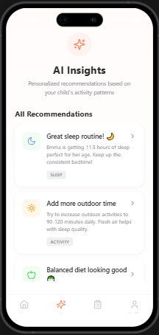
Figure 10: AI Page

This is the AI page where you can view the AI generated insights like recommendations about the child’s data.

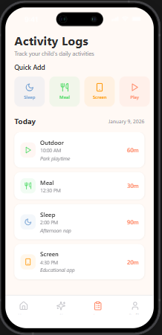
Figure 11: Activity Logs Page

This is the activity logs page where you can enter data about sleep, meals, screen time, and activity.

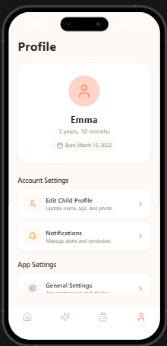
Figure 12: Profile Page

This is the profile page where you can manage the child’s data, notifications, app settings, help & support and the sign out button.

REFERENCES
[1] Yang, F., Wei, J., Zhao, X., & An, R. (2025). Artificial Intelligence–Based Mobile Phone Apps for Child Mental Health: Comprehensive Review and Content Analysis. JMIR mHealth and uHealth, 13(1), e58597.
[2] Weber, S. J., Mulvaney, S. A., Faiola, A., Brown, M., Koyama, T., Sun, L., ... & Hull, P. C. (2023). Commercially available mobile apps with family behavioral goal setting and tracking for parents: review and quality evaluation. JMIR Pediatrics and Parenting, 6(1), e41779.
[3] Hodson, N., Woods, P., Solano, J. L., Talbot, C., & Giacco, D. (2024). Evaluating a mobile app supporting evidence-based parenting skills: thematic analysis of parent experience. JMIR Pediatrics and Parenting, 7(1), e53907.
[4] Shorey, S., Chong, Y. S., Shi, L., Chua, J. S., Mathews, J., Lim, S. H., ... & Law, E. (2023). Evaluating the effects of the supportive parenting App on infant developmental outcomes: longitudinal study. JMIR mHealth and uHealth, 11(1), e43885.
[5] Martinez, R. G., & Haisma, H. (2024). MICG-AI: A multidimensional index of child growth based on digital phenotyping with Bayesian artificial intelligence. arXiv preprint arXiv:2412.14720.
[6] Maier, E. M., Tanczer, L. M., & Klausner, L. D. (2025). Surveillance Disguised as Protection: A Comparative Analysis of Sideloaded and In-Store Parental Control Apps. arXiv preprint arXiv:2504.16087.
[7] Hirushit, S., Raja, S., Suwetha, S., & Yazhini, J. (2024, March). AI Powered Personalized Healthcare Recommender. In 2024 2nd International Conference on Artificial Intelligence and Machine Learning Applications Theme: Healthcare and Internet of Things (AIMLA) (pp. 1-6). IEEE.

